1. Go into BP\KabylakePlatSamplePkg

**2. Run “prep.bat” for DEBUG build**

**Run “prep.bat fspb fspw” for DEBUG build with FSP**

**Run “prep.bat r” for RELEASE build**

**Run “prep.bat r fspb fspw” for RELEASE build with FSP**

**Run “prep.bat f” for flat tree DEBUG build**

**Run “prep.bat f fspb fspw” for flat tree DEBUG build with FSP**

**Run “prep.bat f r” for flat tree RELEASE build**

**Run “prep.bat f r fspb fspw” for flat tree RELEASE build with FSP**

3. Run bld.bat

4. The scripts and images will be at BP\RomImage

  4.1. You can only update the BIOS part image if you did not switch the build mode between normal build and build with FSP.

**KBLX047_00.rom or KBL_FSPWRAPPER_X047_00.rom for Pre-Production type board**

**Prod_KBLX047_00.rom or Prod_KBL_FSPWRAPPER_X047_00.rom for Production type board**

  4.2. If you switched the build mode between normal build and build with FSP, you must update the whole spi image (include ME part).

Go into BP\RomImages folder, run related stepping bat to generate final spi image, for example

**RomImages\KabylakeLp\SunrisepointCx\LP_KBLX047_00_16M_RVP7_Cx.bat for Pre-Production type RVP7 mobile board**

**RomImages\KabylakeLp\SunrisepointCx\LP_KBLX047_00_16M_RVP3_Cx.bat for Pre-Production type RVP3 mobile board**

**RomImages\KabylakeLp\SunrisepointCx\LP_KBLX047_00_16M_RVP7_Cx_Production.bat for Production type RVP7 mobile board**

**RomImages\KabylakeLp\SunrisepointCx\LP_KBLX047_00_16M_RVP3_Cx_Production.bat for Production type RVP3 mobile board**

5. SPI Image build step

Enter BP\RomImages\Fit\SteppingB

6. run fit.exe

7. copy KBL image from BP\RomImages\KabylakeLp\SunrisepointCx to this application.

8. choose Platform Protection in right sheet.

9. in TPM Over SPI Bus Configuration, change Frequency to 48MHz and Enabled to YES

10. click “Ctri + S” and then click Build on top sheet

11. image will generated at BP\RomImages\Fit\SteppingB

Go into “SETUP -> Platform Information Menu” to get Production Type.

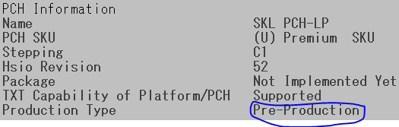

or

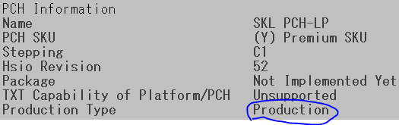

NOTICE: As the KBL code base enabled SPI Quad Mode, that would require dediprog clip to be unplugged after flashing BIOS image.

If you do not want to unplug the dediprog clip after flashing BIOS image, use ####_WithQuadModeDisabled.bat instead.